Experiment 7.3
Fourier Transform of a Continuous-Time Signal
Aim
Compute and plot Fourier transform magnitude and phase.
Program (MATLAB)
% Fourier Transform of a Continuous-Time Signal
clc;
clear;
close all;
% Time axis
t = -5:0.01:5;
% Continuous-time signal
x = exp(-abs(t));
% Fourier Transform using FFT

X = fftshift(fft(x));
% Frequency axis
N = length(X);
f = linspace(-50,50,N);
% Plotting
figure;
subplot(2,1,1);
plot(t,x,'LineWidth',2);
grid on;
title('Continuous-Time Signal x(t)');
xlabel('Time (s)');
ylabel('Amplitude');
subplot(2,1,2);
plot(f,abs(X),'LineWidth',2);
grid on;
title('Magnitude Spectrum |X(f)|');
xlabel('Frequency (Hz)');
ylabel('Magnitude');
Output Generated Graph
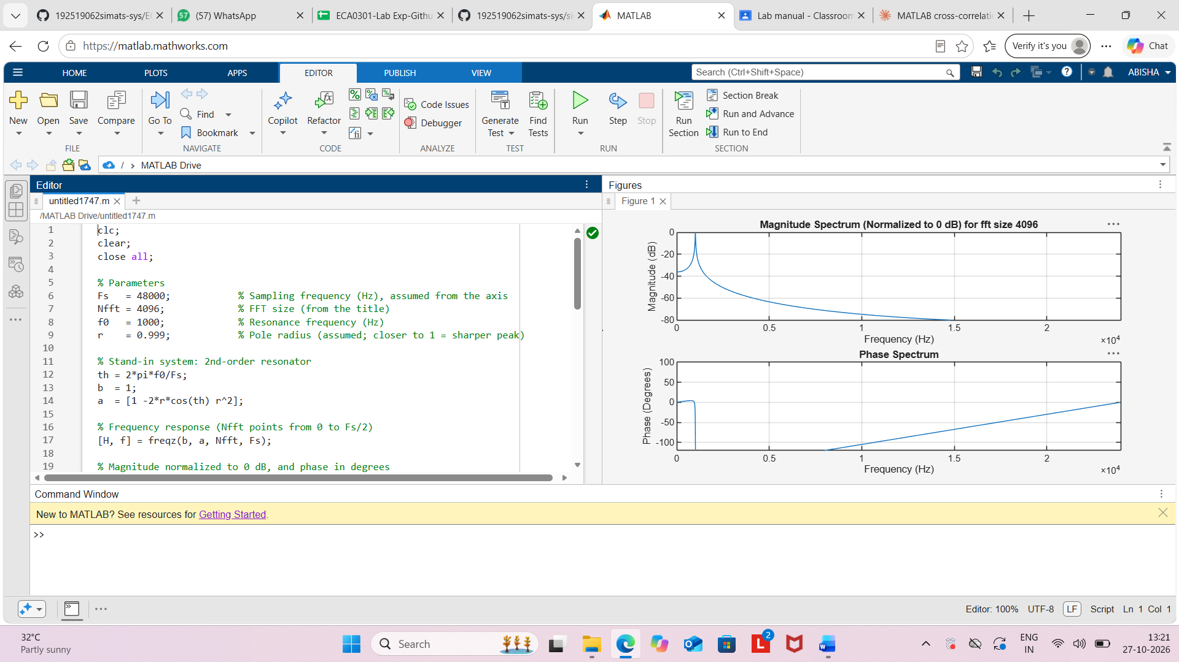
Result
The Fourier Transform of the continuous-time signal x(t)=e−∣t∣ was computed using
MATLAB. The magnitude spectrum was obtained using FFT and showed that most of the
signal energy is concentrated around the zero-frequency component, illustrating the
frequency-domain representation of the signal.

